Poor-Friendly Technology Initiative In Japan:
Grameen Technology Lab

Dr Ashir Ahmed
Koji Ishida
Prof Masaharu Okada
Prof Hiroto Yasuura
Kyushu University
Fukuoka, Japan

Introduction
According to WHO, in 2009 diarrhoea has caused 1.5 million deaths in children under the age of 5, i.e. over 4,000 children died per day. In India alone, more than 1,050 children die of diarrhoea per day. In contrast, a total of 14,286 deaths in the same year were reported, according to the European Centre for Disease Prevention and Control. Thanks to ICT, information about H1N1 flew faster than the virus, and the world took immediate steps to fight the virus. The medicine is affordable: no policy is stopping people from taking proper treatment for diarrhoea. Around 1.5 million deaths a year could be avoided if information could reach these unreached. These deaths do not receive attention of the world community in part because trading surrounding diarrhoea treatment and medicines is not as profitable as H1N1 from the business point of view. Table 1 shows the other equally unfortunate facts:
Table 1: World Facts
Facts | Category
Fact 1: About half of the world (over three billion people) live on less than $2.50 a day | Poverty
Fact 2: According to UNICEF, 24,000 children die each day due to poverty | Poverty
Fact 3: Nearly a billion people entered the 21st century unable to read a book or sign their names | Education
Fact 4: Less than 1% of what the world spent every year on weapons was needed to put every child into school by the year 2000 and yet it didn’t happen | Education
Fact 5: Around 1.1 billion people in developing countries have inadequate access to water, and 2.6 billion lack basic sanitation | Health
Fact 6: Around 1.8 million child deaths each year as a result of diarrhoea | Health
Fact 7: In developing countries around 2.5 billion people are forced to rely on biomass-fuel wood (charcoal and animal dung) to meet their energy needs for cooking. In Sub-Saharan Africa, over 80% of the population depends on traditional biomass for cooking, as do over half of the populations of India and China | Energy
Fact 8: In 2005, the wealthiest 20% of the world accounted for 76.65% of total private consumption. The poorest fifth just 1.5% | Environment
Fact 9: 1.6 billion people (a quarter of humanity) live without electricity | Energy

Kyushu University has undertaken a new research project to redesign the present social information infrastructure. The aim of the project is to establish new social infrastructure to serve social services to the vast majority of the people, e.g. healthcare, education, business, and governmental services. Part of our research focused on developing countries. We conducted a series of surveys in 2008 (see Zabir et al 2008) to understand the present social information infrastructure in a developing country, Bangladesh. We observed in the rural areas in Bangladesh how villagers use Information Communication Technology (ICT). Six hundred (600) villagers in three rural areas were asked which media among newspaper, radio, television, mobile phone and internet they use to access social information such as health, education, business and entertainment. The key finding is that people choose media according to the content. Our results show that 93% watch TV, 90% have access to a mobile phone, 60.9% listen to radio, and 63.4% read a newspaper while only 6% use the Internet. Although basic infrastructures (water, gas or electricity) were absent in these villages, the availability of mobile phones was amazingly high. In order to charge the mobile phones, people bring advanced solar energy sources to the village. Using solar energy, people also operate computers to connect to the outer world for the purpose of confirming their jobs in the Middle East.
A common scenario in most developing countries: the people are keen to access advanced technologies and do not wait for all the infrastructures to be established or for appropriate policies designed. This situation is in sharp contrast to that in the developed world where policy and infrastructure strongly influence what is possible. Thus, it takes a longer period of time to deploy a technology in the complex infrastructures of developed countries because the new technology needs to have backward compatibility with the existing system and policy needs to approve the new technology. This makes deployment costs expensive in terms of both time and money. On the other hand, a place with little or no infrastructure has an open option to accept new and advanced technology. There is no issue of backward compatibility. Deployment costs become relatively cheap. Therefore, the developing world offers a great opportunity for academic researchers, product designers and vendors to enjoy the immediate outcome of their efforts.
Technology can save the developing world from many of the problems that the people face. While some technologies they are getting there, these are not those with the most potential to improve lives. The paper attempts to explore or propose a new technology development process so that the unreached can be reached.

2. Technology / Product Development Process
While budget allocations may have different priorities, a careful technology/product development process can change the scenario. We have sufficient technologies at hand to design products regardless of the income-level of the target users. Projects like World Summit on Information Society (WSIS) by the UN, One Laptop Per Child (1LPC) by the Melinda-Gates Foundation and International Telecommunication Union sTandardisation (ITU-T) are taking different Information and Communication Technology for Development (ICT4D) initiatives to provide sufficient access to social services:
(a) The technologies developed in universities do not necessarily reach their final destination of use in society. Many of them stay on the shelves.
(b) As the commercial industries have to prioritise profit, they select the premium customers. Moreover, in order to stay competitive, they make aesthetic changes to the product to attract the customers. This makes the product price even higher.
(c) Consumers with high incomes in developing countries end up importing the higher priced products with the aesthetic features. Then, these products need to be customised to suit cultural and regional requirements. The price becomes even higher and increasingly unaffordable for the people in low-income brackets. Therefore, a larger portion of the population remains unreached by technologies, products or services.
While fundamental research should continue in universities, space also needs to be created for research on social needs along with technology development. By social needs, we mean the requirements of the masses. The advantages of this approach are that the redundant features can be eliminated in the design phase resulting in a cheaper product price. This will increase accessibility to people in lower income brackets.
3. Projects at the Kyushu University
Currently, there are six major projects running at Kyushu University. All the projects are based on the requirements identified in the surveys conducted by Grameen Communications, Bangladesh.
3.1 Social Information Platform
It is difficult to overcome hurdles faced while conveying information on social services (such as health, education, environment, job, etc) provided by the government, non-government, social development agencies and business agencies to villagers. Villagers, on the other hand, do not have the opportunity to have their voice heard.
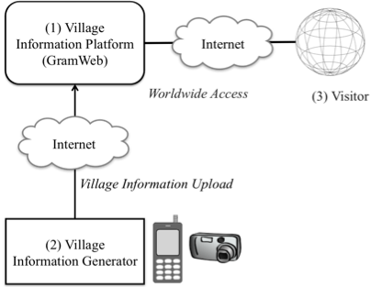
Fig 1: Social Information Platform (www.gramweb.net)
The GramWeb platform (see Ahmed 2009) www.gramweb.net is capable of handling 85,000 village websites, one for each village in Bangladesh.
A Village Information Entrepreneur (VIE), ideally a native villager, collects the village information and uploads it to the allocated space of the GramWeb platform. The villager-friendly interface (designed for both high and low-literate populations) opens new opportunities by allowing villagers to share news, upload photos, trade goods, promote tourism and even interface with local matrimony and job-search portals.
Enabling villagers to broadcast their information to the world brings invaluable benefits not just to the villagers themselves but also to society as a whole. If village information is collected, archived and maintained locally for publication through GramWeb, data can be aggregated with statistics from other villages. These aggregated reports can be sold to third-party organisations and act as a source of income for the villages. Aggregated statistics can help local and national government officials in making policy decisions and provide local and country information to the global organisations such as the UN. The statistics have the advantage of being immediate and up-to-date. For example, conducting a population census in a developing country can take between five to ten years but with the GramWeb framework it can be done in a few seconds.
3.2 ePassbook: An Electronic Gadget for the Poor
ePassbook is a multi-functional electronic card originally developed for microfinance borrowers to maintain their financial records. Grameen Bank uses a manual passbook and had the requirement of digitising it. The bankcards used in developed countries do not satisfy the requirements. Grameen Bank users have more functional requirements that need more technical innovations. For an example, the manual passbook has their loan information which can be viewed at any time. A digital bankcard does not show the loan information. The dimensions of a wallet determine the size of a bankcard. However, Grameen Bank borrowers do not use wallets. Most of the borrowers are women who wear sarees without pockets. The requirements led us to design and manufacture a new card from the scratch. We named it “ePassbook”.
We added a display to our ePassbook (Fig 2) so the records can be viewed. A solar panel is the source of energy for the display. These additional features make the product more expensive, and we are constrained to keep the price affordable.
The core module of a digital card is an IC chip. We have selected Kyushu University’s IC chip having the capacity to support multiple services. By allowing multiple services on the same card, the service-provider can share the cost of the device. Out of many potential services that are required by the poor, we decided to start with three: health records at the patient end, ecommerce, and money transfer. These services can subsidise the cost. For example, if an archive of millions of people’s health records can be used by researchers as an invaluable information source to see disease trends, the statistics can benefit the government, WHO and social development organisations. The statistics (removing private information) can be a source of income for the ePassbook card issuers. This way, the cost of the device can be subsidised.
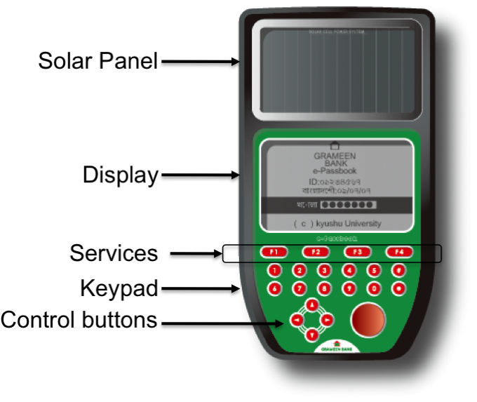  Fig 2: ePassbook: an electronic gadget for the poor | 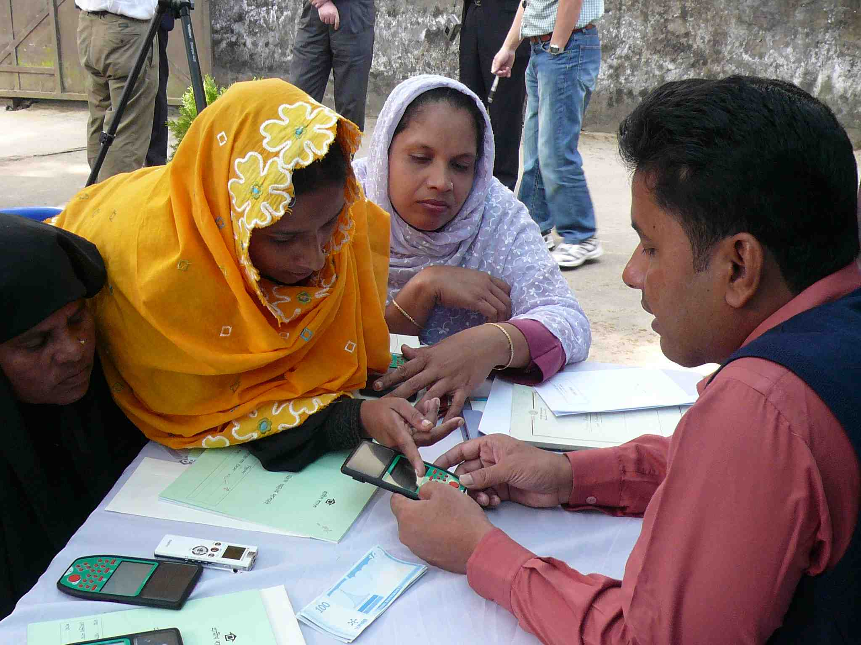  Fig 3: Microfinance borrowers and managers test the usability of ePassbook

3.3 Affordable ($300) Portable Clinic
In section 3.2 we discussed about the health record to be maintained at the patient side in ePassbooks. There are standard electronic health record (EHR) schemes in different areas of the world. We observed that microfinance borrowers become a member of a microfinance institute as a family unit (see Rahman et al 2010). Therefore, an ePassbook will be offered to a family, not to an individual. The proposed EHR will also will be family-based, not a personal device. A new set of challenges have appeared: how to design a family health record (FHR) system and how to insert FHR into the ePassbook. We have designed a health check up booth equipped with nine most common diagnostic tools. The booth can be set up in a village clinic or in a community place where the villagers can come for a check. A medical health assistant will be required to assist the villagers and maintain the health booth.
Traditionally, there were ‘village doctors’ who used to visit homes. In other words, the culture is one where doctors visit patients, rather than the other way around. To keep this tradition intact, we needed advanced technology to satisfy all concerned parties - patients, doctors and government. We are proposing a $300 portable clinic (Fig 6). The proposed clinic is a box consisting of different diagnostic tools, a display and a communication interface. A health assistant in the rural areas (preferably, a Grameen nurse) can carry the clinic box to the patients’ homes. Tools in the box are to collect diagnostic data, and send them to a doctor in an urban area. The doctor can provide necessary instructions to the nurse. This box will create opportunities for medical equipment vendors to design and develop diagnostic tools, and for software vendors to structure these diagnostic tools in such a way that a nurse with a minimum of training can operate.
This portable clinic can address the health issues of billions. Unreached people will have opportunities to consult with a remote doctor with instant pathological test results. This will create job opportunities in remote areas. Education on healthcare can gradually improve in villages. A doctor does not have to travel all the way to the village. We anticipate millions of such ‘clinic tools’ boxes will be required, resulting in the creation of business for advanced medical equipment vendors, software vendors and healthcare service providers. The health checkup box is already developed (Fig 4) and being tested in Bangladesh. We are currently carrying out a feasibility study for the $300 portable clinic.

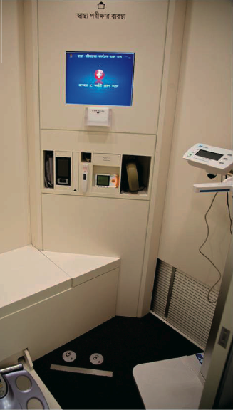  Fig 4: Health Check-up Booth. Various diagnostic tools collect health data and store them in ePassbook. | 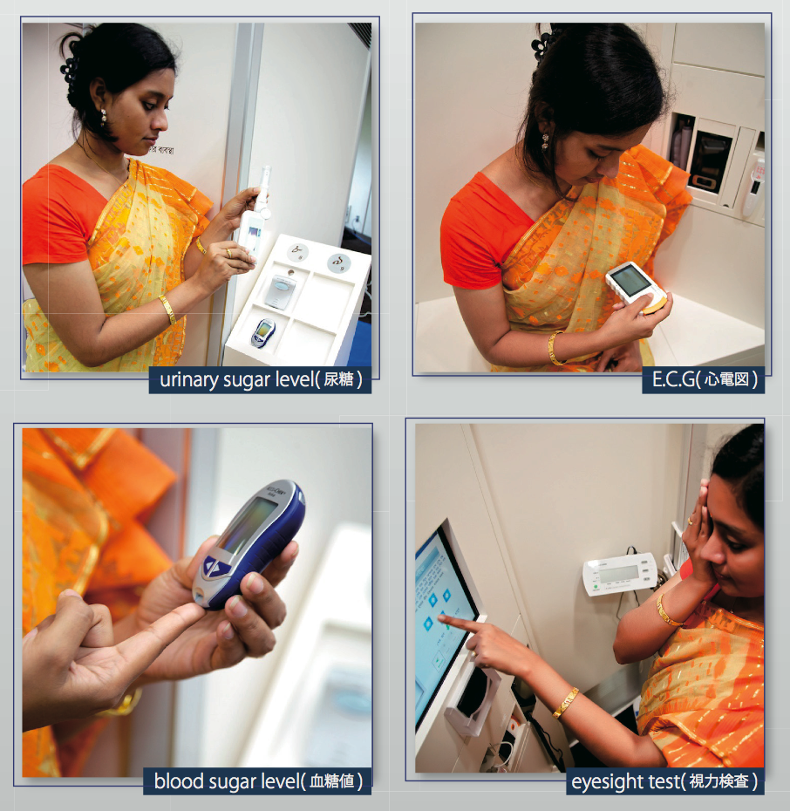  Fig 5: Electronic diagnostic tools producing on-site test results
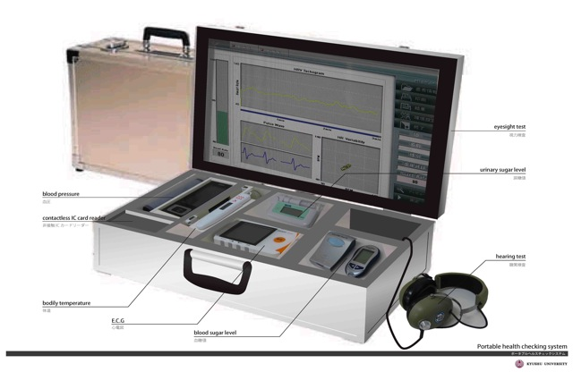
Fig 6: $300 Portable Clinic, with all the functions of a booth (as in Fig 4), can be mounted in a suitcase. A Grameen nurse can easily visit patients’ homes.

3. Social Business in Japan: Background and Present Status
Japanese people are highly inspired by the concept of “Social Business” coined by Professor Yunus (2007, 2010). The so-called seven principles of social business overlap with what Japanese industries have been practising for hundreds of years. The current profit-maximisation business process is creating bigger gaps between poor and the rich. In a typical company in the US, the salary of a company ‘President’ is 1,000 times bigger than a new employee in the same company, while it is only 10 times higher in Japan. Japan meets the requirement of ‘social business’ in the sense that employers do not make excess profits for themselves. They offer their resources more for their customers. We are also aware of the limitations of NGOs and NPOs which are suffering from the sustainability issue. In Japan, there are more than 3,000 companies operating their business for more than 200 years and 7 companies for more than 1,000 years. This sustainability proves how carefully they have served their society. Japanese people already have some sort of social business DNA in their company culture.
We have already created three social business entities in Japan: Grameen YukiGuni Maitake Ltd, Grameen Uniqlo and Grameen Technology Lab. Two Grameen Creative Labs have been established in two Japanese universities - Rikkyo University in Tokyo and Kyushu University in Fukuoka.
3.1 Grameen Yukiguni Maitake Co Ltd
The objective of this ‘social business joint-venture’ is to enhance the income of farmers, particularly for the village women who will be engaged in the processing of mung beans for the export market. The company will also offer healthcare services and scholarships to children of these farmers, as well as bringing new technologies to them.
This joint-venture company has three partners: YukiGuni Maitake Co Ltd of Japan to provide technical know-how, Kyushu University to carry out joint academic research to build case studies on ‘social business’ between Grameen and other Japanese industries. Grameen Krishi Foundation will assist in organising the local farmers.
Bangladeshi farmers in general, produce mung beans and eat them as beans in the form of lentil-soup. On the other hand, sprouts produced from the beans will have 1.5 times more nutrients. Beans of 4 mm or longer are appropriate for sprouts while smaller beans can be utilised as soup. It is expected that 70% of the beans will qualify for export.
Bangladeshi farmers will be benefited in three ways: generating more income by growing the beans and exporting them to Japan, creating new job opportunities for sorting of the beans (>4mm beans need to be sorted manually), and engaging in business to sell the beans in local market too.
3.2 Grameen UniQlo
The objective of this company is to produce affordable women’s underwear, school uniforms and blankets. Women in developing countries do not use proper sanitary napkins. Affordable sanitary napkins and underwear can protect them from many female-specific diseases. People in the northern areas of Bangladesh suffer from sudden cold in winter. Grameen UniQlo is established to address these issues.
The company plans to hire up to 2,000 local people within three years, mainly from the borrowers of Grameen Bank, and train them to become financially independent by selling clothes.
3.3 Grameen Creative Lab at Kyushu University
Grameen Creative Lab at Kyushu University (GCL@KU) was established in March 2010, based on the MOU signed between Kyushu University and the Grameen in 2009. Kyushu University, in general, actively promotes not only a world-wide contribution through the dissemination of customised university resources based on the needs of developing countries, but also fosters excellent human resources to play an important role in thinking about and creating a better society. GCL@KU consists of researchers from different departments (engineering, medicine, agriculture, economics, etc) working on education and research for the incubation and dissemination of social business. GCL@KU works in collaboration with the Grameen companies, NPOs, NGOs, other universities and governments.
The following is an outline of the key activities of GCL@KU:
Research: Gather an inter-disciplinary research team within and outside the university to solve targeted social issues; create global joint research opportunities utilising the worldwide GCL networks; assist and cooperate with Grameen Technology Lab, etc.

Education: Build a curriculum for the design and implementation of social business; promote global joint education programmes with GCL@University; foster social business ideas from the students, etc.

Incubation: Support for social business ideas from students, companies and individuals so that that can move into a practical phase; arrange competition for social business ideas, etc.

Promotion: Organise social business workshops and symposia; deliver lectures to companies, governments and other external organisations, etc.

4. Grameen Technology Lab
Grameen Technology Lab is a proposal for a ‘social business entity’ that can examine how technology development organisations can run as social businesses. The above mentioned ePassbook project was financially supported by JETRO, designed by university researchers, and manufactured by Japanese vendors. Grameen provided the experimental support. The university took the lead in the project by identifying the social needs, designing the product and managing the development and experiment. In the end, government, academia, industry and society were all engaged in the creation of the product. The project resulted in a win-win situation for all concerned. Through this experiment, we designed a product considering social needs and confirmed the market of million customers. A further salient point is that the same technology has been reversely imported and is being used in an experiment in Itoshima City in Japan.

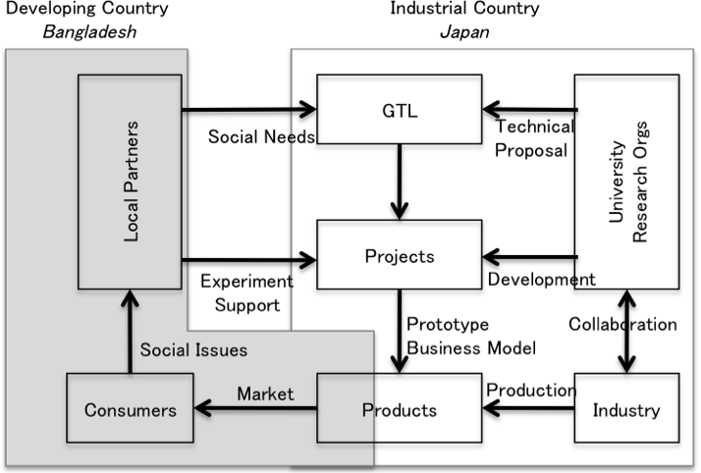
Fig 7: Social needs-based research: product development diagram
NGOs and NPOs have expertise on social problems and needs. On the other hand, research organisations have the most advanced technologies as well as the human resources to solve social issues. In order to make a bridge between the society and research institutes, Fig 7 shows the framework which is used in GTL (Grameen Technology Lab). Depending on the social needs that are identified by the local partners, GTL gathers appropriate technologies or proposals from research organisations.
Technologies developed in the research institutes will find a way to become useful in society. Industries partnering with the local counterpart for developing and distributing the product will help deliver the product at consumers’ doors. Currently, a developing country like Bangladesh is a recipient of financial support as donations from advanced countries like Japan. However, for the long term, we hope to see the donations turning into technical knowledge transfer in a sustainable business scheme to solve social issues of 4 billion largely unreached people in the world, including Bangladesh.
5. Conclusion
This article introduces a new approach to the development of affordable and income-generating technologies considering the requirements of the hitherto unreached. We introduced three of our major ICT-related innovations: ePassbook to record financial and health-related information; a social information platform where villagers can gather information on their own and share it with the world as a business; and a portable clinic. Grameen Technology Lab in now engaging with the community to identify social needs, with industries to put their technical know-how to best use, with academia for long-term research, and with other social business entities to disseminate the products to the target bottom population. Similar to so-called seven principles of social business now practically overlap with what Japanese industries have been practising for hundreds of years. Profit-maximisation industries that have forgotten or are unaware of these principles can reset some of their policies to step into the world of social business. Through GCL and GTL activities, the Kyushu University will continue promoting the ‘social business’ concept to students, researchers and its collaborative research partners.
Acknowledgement
The authors are thankful to Professor Osugi of Kyushu University, Professor Muhammad Yunus and Nazneen Sultana of the Grameen, Dhaka, Bangladesh.

References
Ahmed, Ashir (2009): “An Information Production and Ownership Platform for BoPers”, Proceedings of IADIS International Conference ICT, Society and Human Beings, Portugal: IADIS Press, June, Pp147-154.
Ahmed, Ashir (2010): “ePassbook: An Electronic Gadget for the Poor”, Business Magazine-Wheel, Vol 1 No. 3, October-December, 2010. www.wheel.com.bd
Rahman, Asifur., Ahmed, Ashir and Ohsugi, Takuzo (2010): “Key Challenges to the Expansion of Microfinance Industries in Bangladesh: Case Studies on Grameen, ASA and BRAC”, Bulletin of Kyushu University Asia Center, March.
Yunus, M (2007): Creating a World Without Poverty: Social Business and The Future of Capitalism, New York: Public Affairs.

Yunus, M (2010): Building Social Business: The New Kind of Capitalism That Serves Humanity’s Most Pressing Needs, New York: Public Affairs.

Zabir, SMS, Ahmed, Ashir and Yasuura, Hiroto (2008): “Digital Divide: The Amazing Fact at the BOP”, IADIS International Conference on ICT, Society and Human Beings, Amsterdam, The Netherlands, July.

http://whqlibdoc.who.int/publications/2009/9789241598415_eng.pdf; Mothers of these children were asked, What did you do when your kid had diarrhea? Did you stop feeding liquids or provide more liquids? Thirty five percent answered: “stopped feeding liquids”.
"ECDC Daily Update – Pandemic (H1N1) 2009 – 18 January 2010", European Centre for Disease Prevention and Control.
See Anup Shah, “Poverty Facts and Stats”, http://www.globalissues.org/article/26/poverty-facts-and-stats
Ahmed (2010).

